A | C | B | C | D | D | E | F | G | H | I | J | K | L | S | H | E | L | L | S
M | R | N | O | P | E | Q | R | S | T | U | V | W | C | X | Y | Z | B | C | D
E | A | F | G | H | E | G | I | G | G | L | E | D | I | O | J | K | L | M | N
O | B | P | Q | R | P | S | S | T | U | V | W | X | Y | Z | R | C | D | E | F
G | H | I | J | K | L | M | T | N | O | P | Q | R | S | T | U | A | V | W | X
Y | Z | D | E | F | G | H | E | I | J | K | L | M | N | O | P | Q | L | R | S
T | S | U | V | W | X | Y | V | Z | E | F | G | D | A | R | K | H | I | J | K
L | O | M | N | O | P | Q | I | J | E | L | L | Y | F | I | S | H | R | S | T
U | R | V | W | X | Y | Z | E | F | G | H | I | J | K | L | M | N | O | P | Q
R | R | S | B | L | U | E | T | U | V | W | X | Y | J | A | K | E | Z | F | G
H | Y | I | J | K | L | M | N | O | P | S | W | I | G | G | L | E | D | Q | R
S | T | U | V | W | X | Y | Z | G | H | W | I | J | K | L | M | N | O | P | Q
R | F | R | I | E | N | D | S | S | T | I | U | V | W | X | Y | Z | H | I | J
K | L | M | N | O | P | Q | R | S | T | M | S | H | A | R | K | Z | I | J | K
L | M | N | O | P | Q | R | S | T | U | V | W | X | Y | Z | J | K | L | M | N
O | P | S | T | U | N | G | Q | R | S | T | U | V | W | X | Y | Z | S | E | A

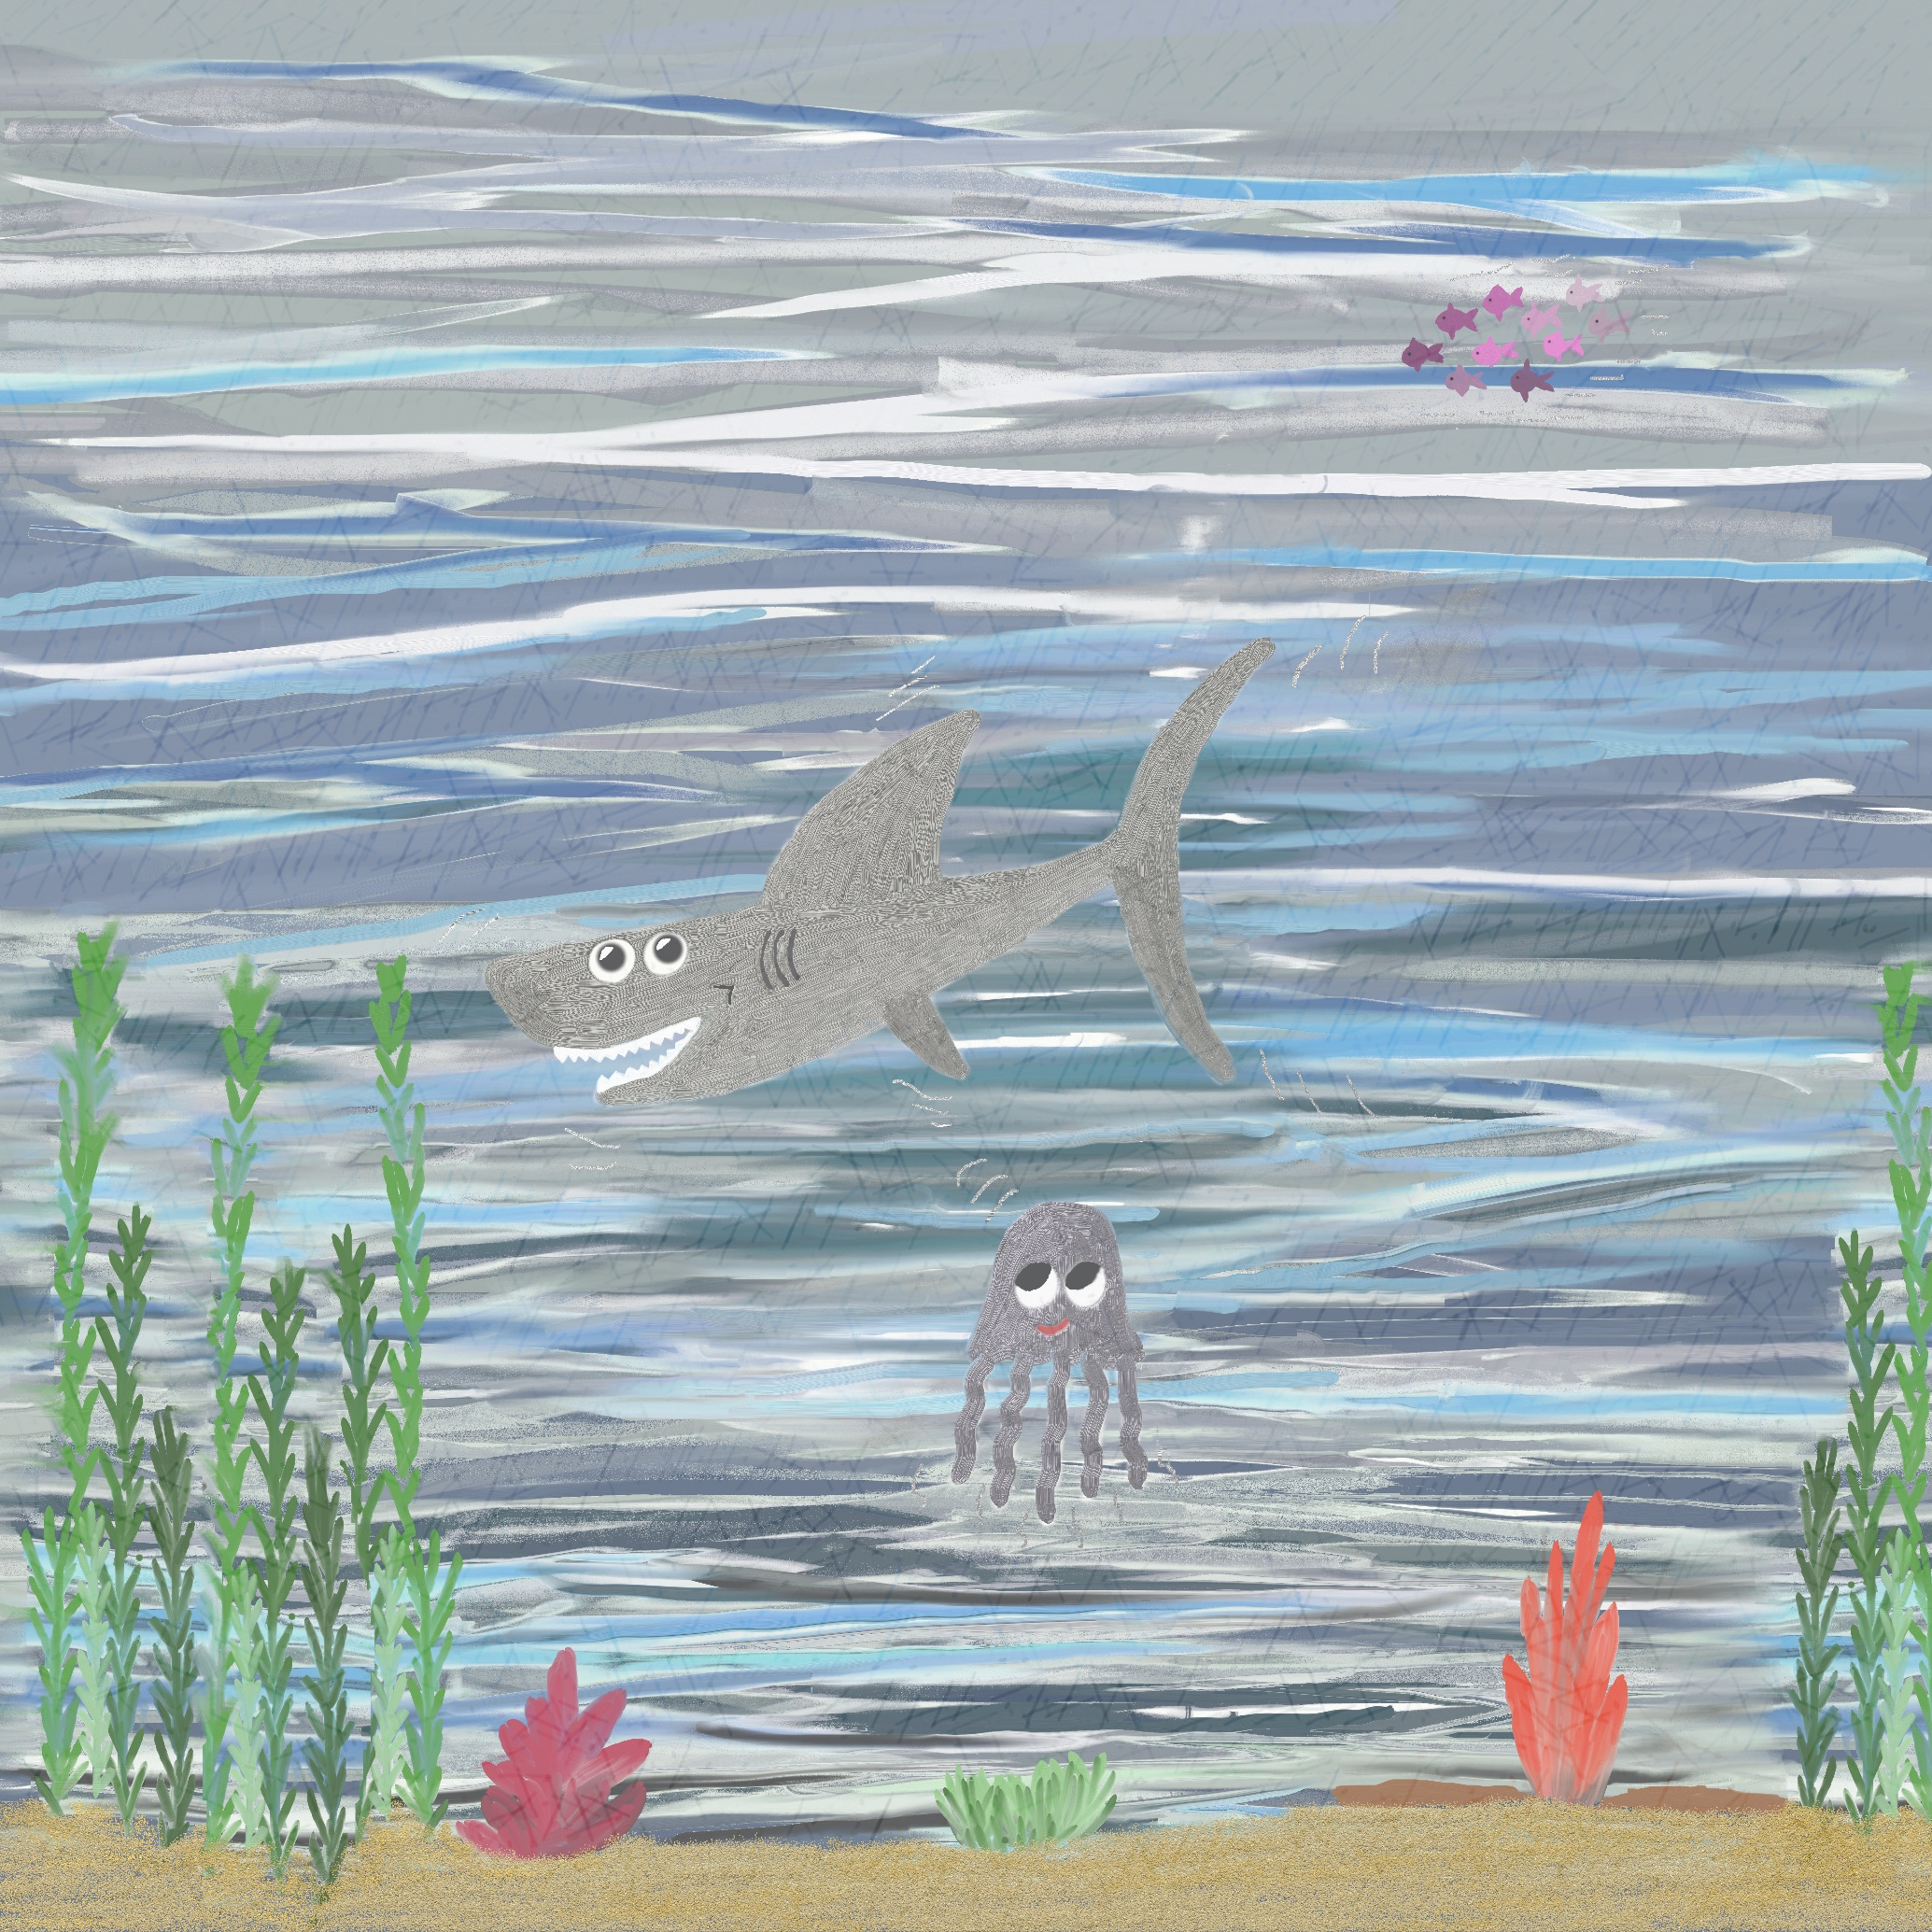
Free Printable Resources from Flower Guard Books © Andi Dawson
STEVIE SHARK JAKE JELLYFISH SEA STUNG FRIENDS CRAB DEEP CORAL DARK WIGGLED GIGGLED SWIM SORRY BLUE SHELLS

