
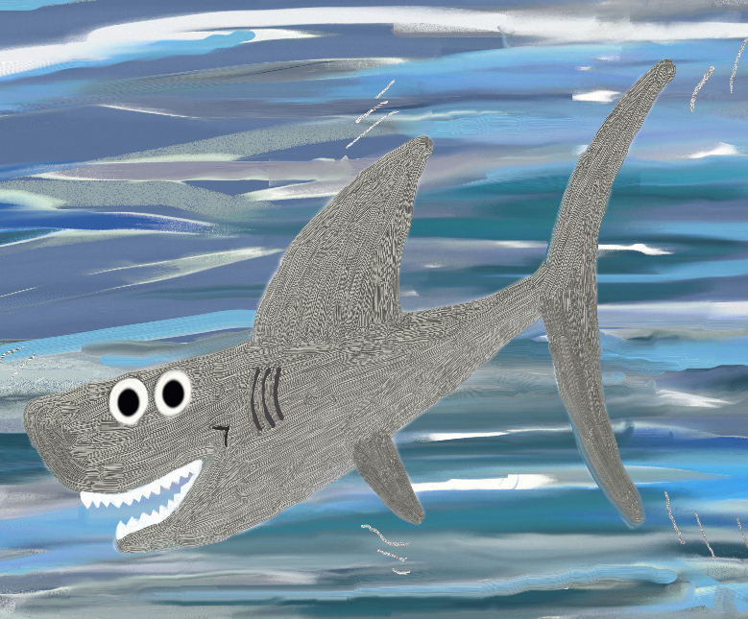
Free Printable Resources from Flower Guard Books © Andi Dawson
Can you describe your character?
____________________________________________________________________________________
___________________________________________________________________________________
___________________________________________________________________________________
___________________________________________________________________________________
___________________________________________________________________________________
What does your character love to do?
___________________________________________________________________________________
___________________________________________________________________________________
___________________________________________________________________________________
___________________________________________________________________________________
___________________________________________________________________________________
Where will Stevie the Shark meet your character?
___________________________________________________________________________________
___________________________________________________________________________________
___________________________________________________________________________________
___________________________________________________________________________________
___________________________________________________________________________________
Draw your character…
Stevie the Shark and _______________________________
Name: ________________________________________

