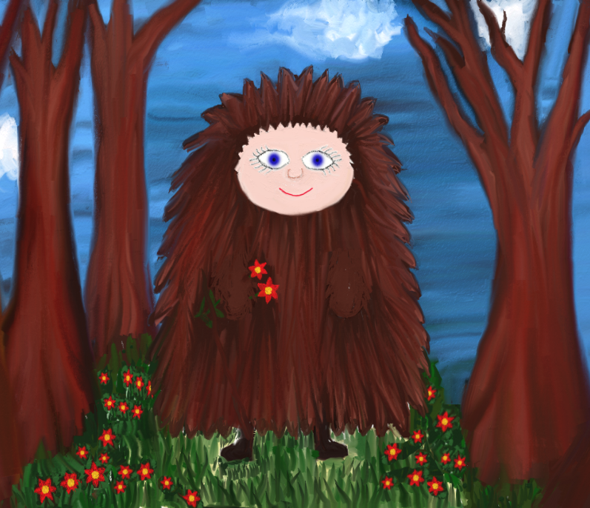
Draw your character…
What does your character love to do?
___________________________________________________________________________________
___________________________________________________________________________________
___________________________________________________________________________________
___________________________________________________________________________________
___________________________________________________________________________________
Where will The Creature meet your character?
___________________________________________________________________________________
___________________________________________________________________________________
___________________________________________________________________________________
___________________________________________________________________________________
___________________________________________________________________________________
Can you describe your character?
____________________________________________________________________________________
___________________________________________________________________________________
___________________________________________________________________________________
___________________________________________________________________________________
___________________________________________________________________________________
The Creature and _______________________________
Name: ________________________________________

