s
Circle the sharks with the letter

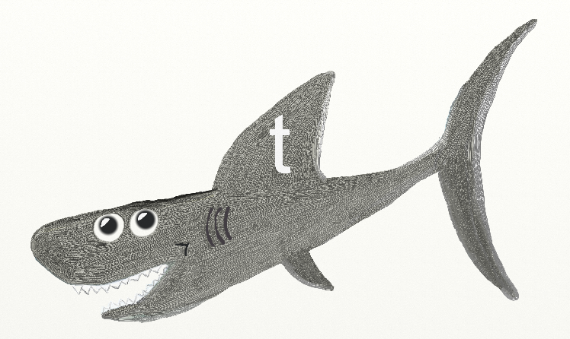
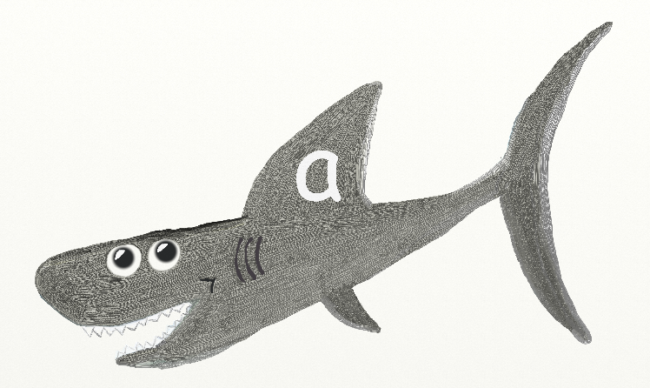


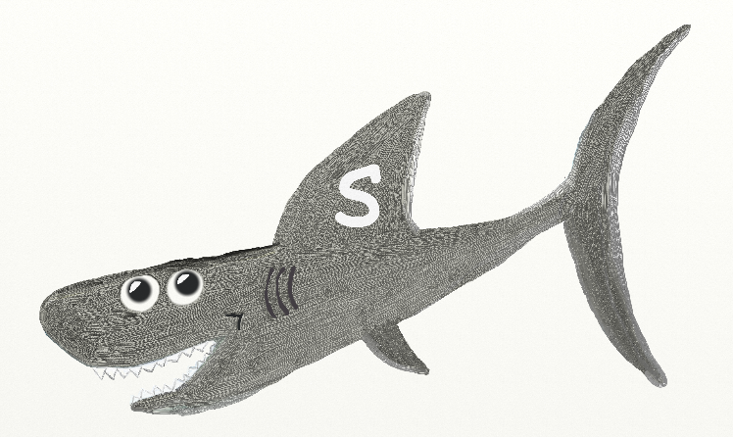
Free Printable Resources from Flower Guard Books © Andi Dawson

a
Circle the sharks with the letter

Free Printable Resources from Flower Guard Books © Andi Dawson
t
Circle the sharks with the letter

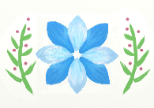
Free Printable Resources from Flower Guard Books © Andi Dawson

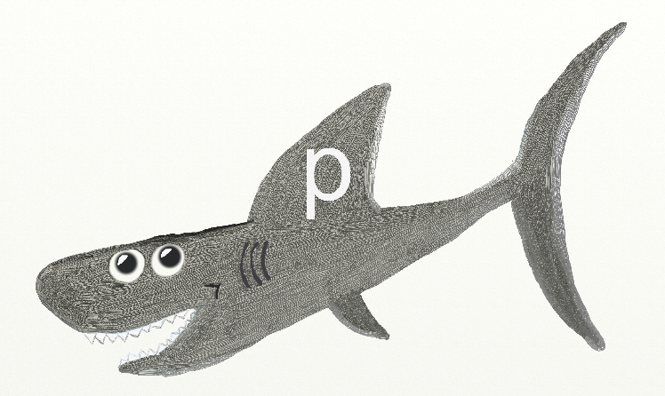
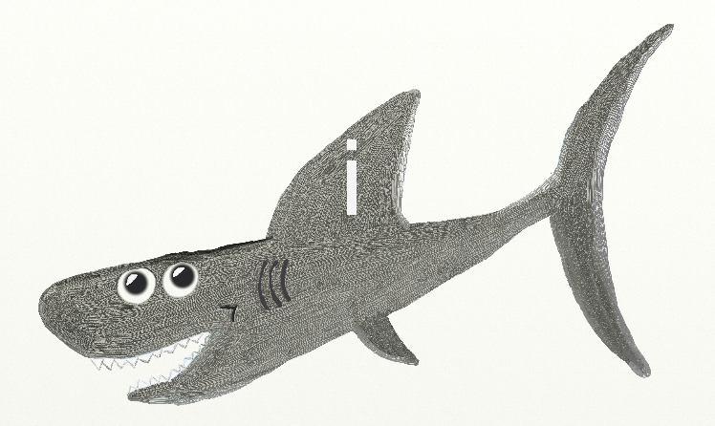
p
Circle the sharks with the letter

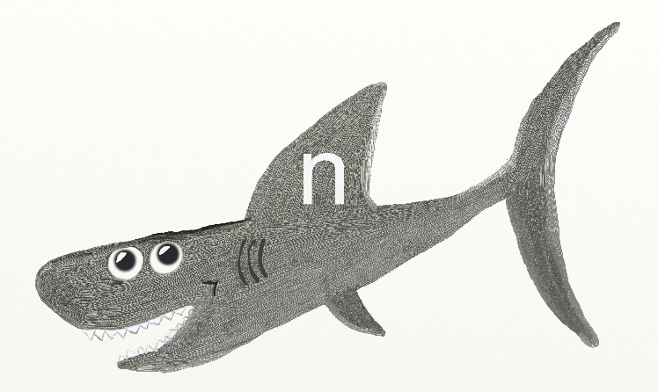
Free Printable Resources from Flower Guard Books © Andi Dawson
Free Printable Resources from Flower Guard Books © Andi Dawson
i
Circle the sharks with the letter

n
Circle the sharks with the letter

Free Printable Resources from Flower Guard Books © Andi Dawson

