
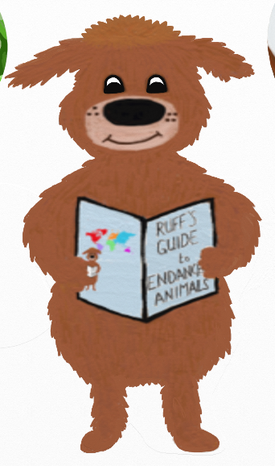
Can you explain why you would adopt this animal?

Can you draw the animal you would adopt?
Ruff has loved meeting all of the animals in his book and he hopes you’ve enjoyed finding out about them too. He would love to find out which animal you would adopt from the WWF if you could.
Which animal would you adopt?

