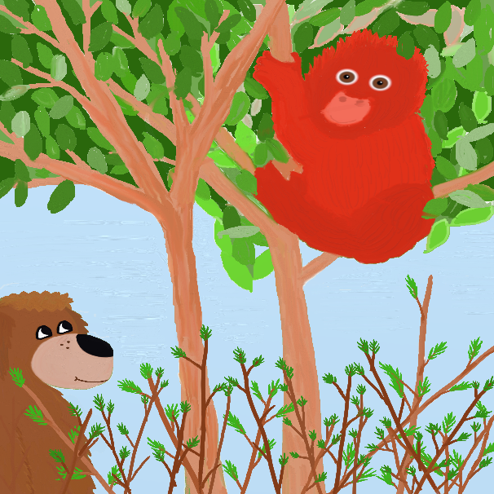 | 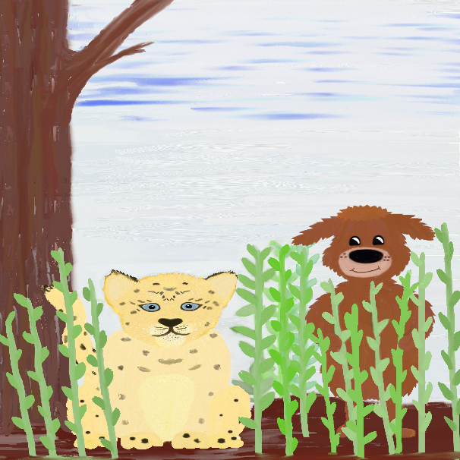 | 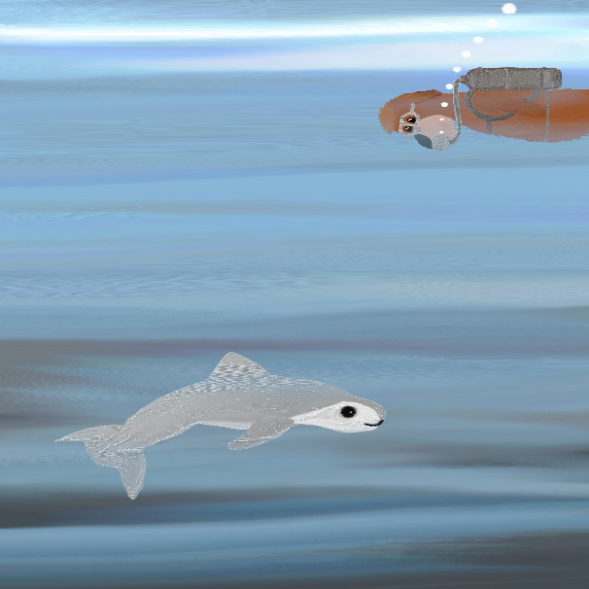
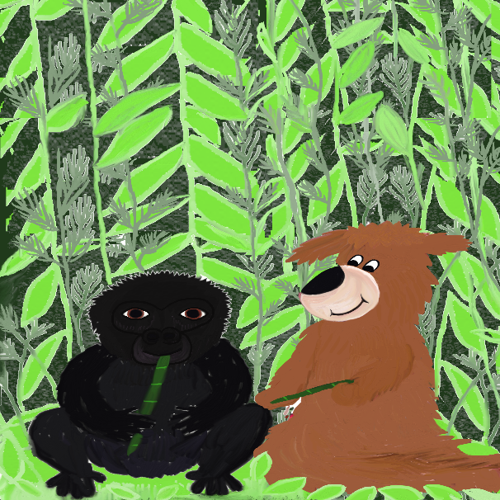 | 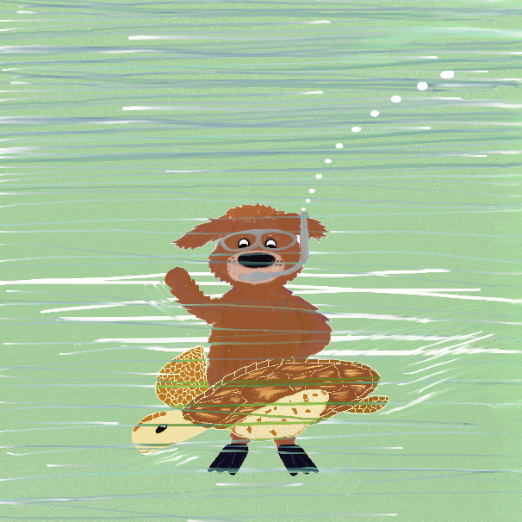 | 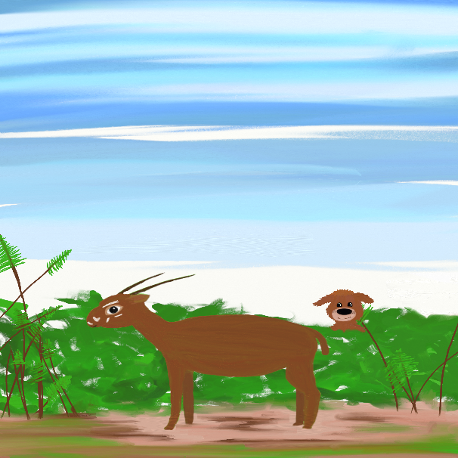
Ruff’s Guide to Endangered Animals Bingo from Flower Guard Books
Ruff’s Guide to Endangered Animals Bingo from Flower Guard Books
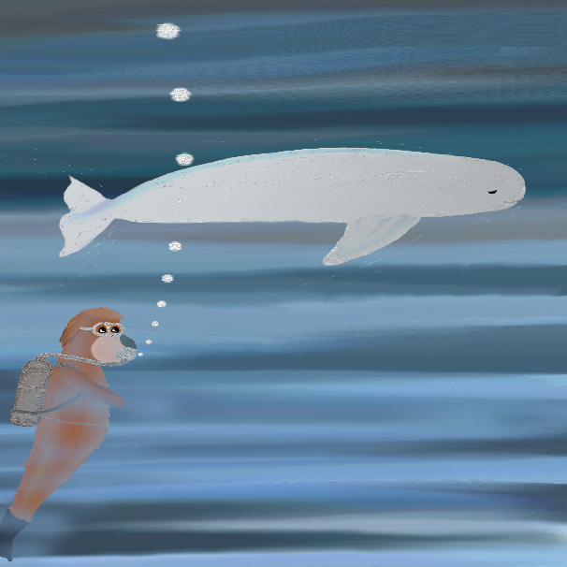 |  | 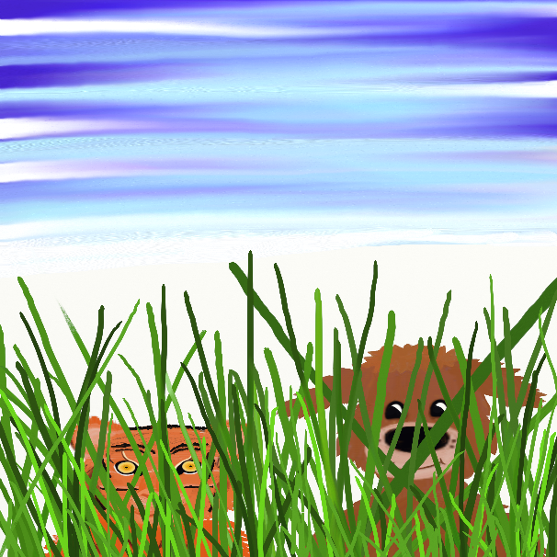
 | 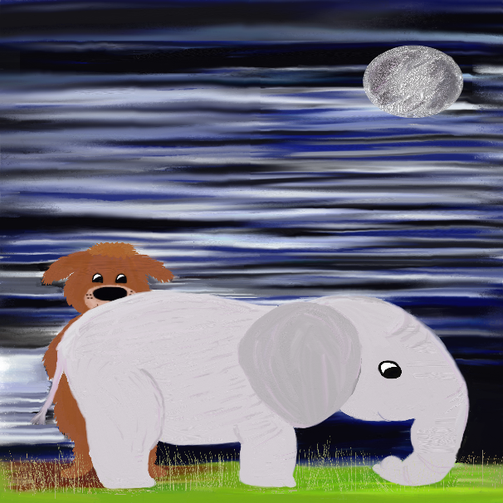
Ruff’s Guide to Endangered Animals Bingo from Flower Guard Books
Ruff’s Guide to Endangered Animals Bingo from Flower Guard Books
Ruff’s Guide to Endangered Animals Bingo from Flower Guard Books
Ruff’s Guide to Endangered Animals Bingo from Flower Guard Books
Ruff’s Guide to Endangered Animals Bingo from Flower Guard Books
